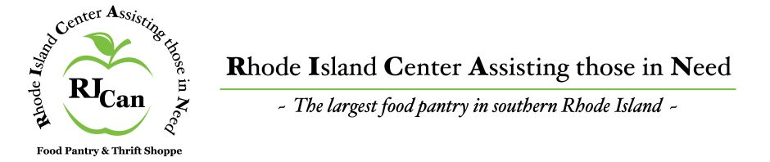

RELEASE AND WAIVER OF LIABILITY, ASSUMPTION OF RISK, AND INDEMNITY PHOTOGRAPH RELEASE AND PARENTAL CONSENT AGREEMENT (“AGREEMENT”)
In consideration of participating in the POLAR PLUNGE, I represent that I understand the nature of the event and that I and/or my minor child am qualified, in good health, and proper physical condition to participate in such event. I acknowledge that if I/or my minor find event conditions to be unsafe, I will immediately discontinue participation in the event.

I fully understand the event involves risk for serious bodily injury, including permanent disability, paralysis and death, which may be caused by my own actions, inactions, those of others participating in the event, the conditions in which the event takes place, or the negligence of the “releasees” named below; and that there may be other risks either not known to me or not readily foreseeable at this time; and I fully accept and assume all such risks and all responsibility for losses, costs and damages I incur as a result of my participation in the event. I hereby release, discharge and covenant not to sue The Rhode Island Center Assisting those in Need and/or the Town of Charlestown RI, their respective administrators, directors, agents, officers, volunteers, employees, other participants, any sponsors or advertisers, (each considered one of the “RELEASEES” herein) from all liability, and assumption of risk I, or anyone on my and/or my minor child’s behalf, makes a claim against any of the releasees, I will indemnify, save and hold harmless each of the releases from any loss, liability, damage, or cost which any may incur as the result of such claim.

I hereby consent and authorize the use and reproduction by The Rhode Island Center Assisting those in Need and/or the Town of Charlestown or anyone authorized by The Rhode Island Center Assisting those in Need and all photographs which are taken of me or my minor child this day, negative or positive, in any purpose in conjunction with the POLAR PLUNGE without further compensation to me.

I have read this release and waiver of liability, assumption of risk, and indemnity, photograph release and parental consent agreement and fully understand it.

Printed Name Date

Signature of Participant or if Under 18 Signature of Parent or Legal Guardian

